**CSE 572: ACTIVITY RECOGNITION PROJECT**

**Team 21:**

Sucharitha Rumesh - 1213120166 - <srumesh@asu.edu>

Shiva Chandrashekhar - 1215106256 - <snchand1@asu.edu>

Ryan Ang - 1206143792 - <rang1@asu.edu>

Akhila Muthyala - 1213175494 - <amuthyal@asu.edu>

Nikhilesh Sadasivam - 1215175247 - <nsadassi@asu.edu>

# Assignment 3

For assignment 3, we picked users 10 through 31 and the utensil “spoon” to test machine learning. From the data in GroundTruth folder, we selected the first row for each user. One row was considered one eating action. The row was multiplied by 50 and divided by 30 to get the row number in the data from MyoData. The Myodata contained sensor data and we used “accelerometer”.

After getting 20 users’ eating data, we then selected the first non eating data from GroundTruth from each user.

To build the input for machine learning techniques, Decision Tree, Neural Network, and Support Vector Machine, we took 60% of the data as training and 40% as testing. Since there were 20 eating actions and 20 non eating actions, a total of 24 actions was used as testing and a total of 8 actions was for training. The following sections are five feature extractions, “Discrete Wavelet”, “Average”, “Fast Fourier Transform”, “Root mean square” and “Standard Deviation”. Once the training and testing of the the user data was done in the Decision Tree, Neural Network and Support Vector machine, the trained machines are used to predict the classification of the eating action for 20 users. For the classification of the 20 users data, the Support vector machine has shown consistent results over all the 5 different types of feature extracted data when compared to the Decision tree or Neural network. The performance of these Machine learning algorithms are measured by calculating the three performance metric: Precision, Recall and F1.

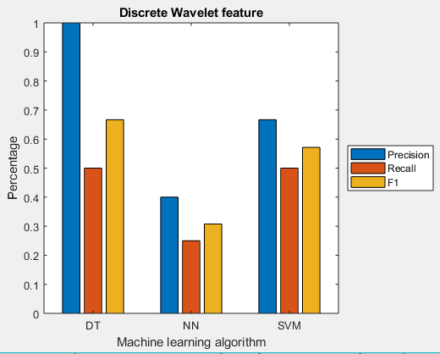

Using SVM, training 24 users for on feature "Discrete Wavelet" produces

Precision 0.67

Recall 0.50

F1-Score 0.57

Using DT, training 24 users for on feature "Discrete Wavelet" produces

Precision 1.00

Recall 0.50

F1-Score 0.67

Using NN, training 24 users for on feature "Discrete Wavelet" produces

Precision 0.40

Recall 0.25

F1-Score 0.31

While predicting using the Discrete wavelet feature, the Decision tree has shown a better performance based on Precision and F1 when compared to the other two algorithms.

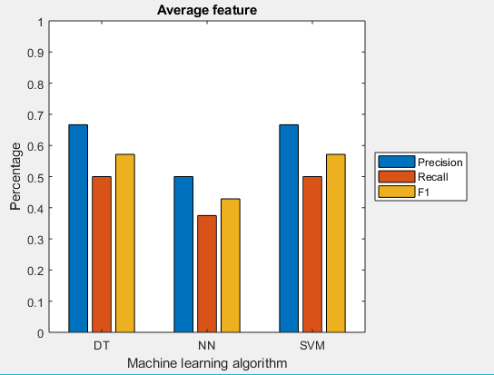

Using SVM, training 24 users for on feature "Average" produces

Precision 0.67

Recall 0.50

F1-Score 0.57

Using DT, training 24 users for on feature "Average" produces

Precision 0.67

Recall 0.50

F1-Score 0.57

Using NN, training 24 users for on feature "Average" produces

Precision 0.50

Recall 0.38

F1-Score 0.43

Using the average feature to classify the data, all the machines have a similar performance. The Support Vector machine has an equal performance with the Decision Tree.

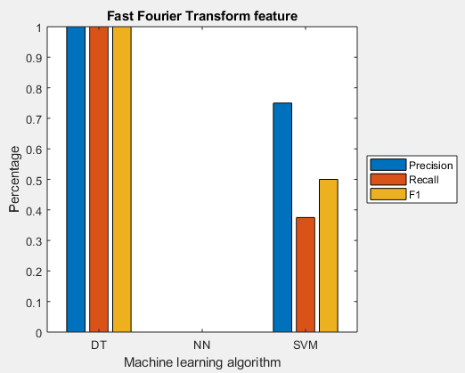

Using SVM, training 24 users for on feature "Fast Fourier Transform" produces

Precision 0.75

Recall 0.38

F1-Score 0.50

Using DT, training 24 users for on feature "Fast Fourier Transform" produces

Precision 1.00

Recall 1.00

F1-Score 1.00

Using NN, training 24 users for on feature "Fast Fourier Transform" produces

Precision 0.00

Recall 0.00

F1-Score 0.00

Using the Fast Fourier Transform features to predict, the Decision tree has an absolute performance compared to the other machines based on these performance metric.

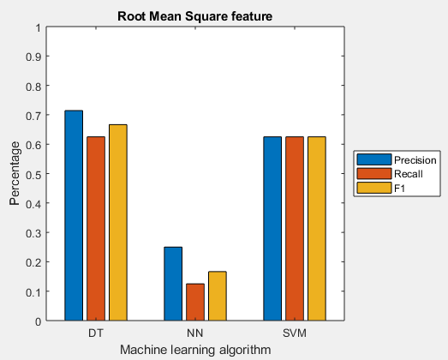

Using SVM, training 24 users for on feature "Root Mean Square" produces

Precision 0.63

Recall 0.63

F1-Score 0.63

Using DT, training 24 users for on feature "Root Mean Square" produces

Precision 0.71

Recall 0.63

F1-Score 0.67

Using NN, training 24 users for on feature "Root Mean Square" produces

Precision 0.25

Recall 0.13

F1-Score 0.17

The Decision tree algorithm has better performance for classifying using Root mean square as the feature, But the Support vector Machine has a consistent performance over the three performance metrics.

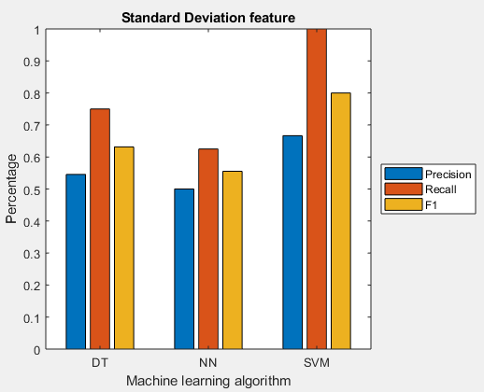

Using SVM, training 24 users for on feature "Standard Deviation" produces

Precision 0.67

Recall 1.00

F1-Score 0.80

Using DT, training 24 users for on feature "Standard Deviation" produces

Precision 0.55

Recall 0.75

F1-Score 0.63

Using NN, training 24 users for on feature "Standard Deviation" produces

Precision 0.50

Recall 0.63

F1-Score 0.56

The Support Vector Machine has a better overall performance over classifying the data. Using the Standard Deviation for feature selection, the Support Vector machine has a performance when compared to Neural Network and Decision Trees.